**Mini USB Adapter**

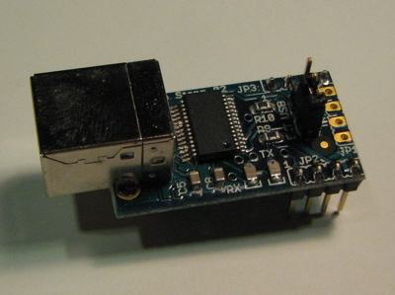

*Photo of an original Mini USB Adapter*

|  |
| --- |
| [http://arduino.cc/en/uploads/Main/buttonDistributors.jpg](http://arduino.cc/en/Main/Buy) |

**Overview**

This board converts a USB connection into 5 volt TX and RX that you can connect straight to the Arduino Mini or other microcontrollers, allowing them to talk to the computer. It is based on the FT232RL chip from FTDI ([drivers](http://www.ftdichip.com/Drivers/VCP.htm) are included with the Arduino software).

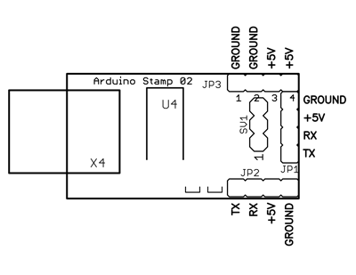

*Pinout of the original Mini USB Adapter*

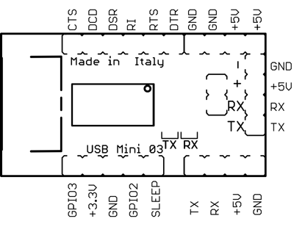

*Pinout of the revised Mini USB Adapter*

[Attach:mini_usb_schematic.pdf](http://arduino.cc/en/uploads/Main/mini_usb_schematic.pdf)

**Connecting to the Arduino Mini**

See the [guide to the Arduino Mini](http://arduino.cc/en/Guide/ArduinoMini) for information on connecting the adapter to the Mini.

**COMMENTS**

https://id.arduino.cc/avatars/proron.jpg

proron Monday, February 11, 2013

Re : the guide to the Arduino USB Mini : Maybe it is good to remark that to connect the USB Mini as in the shown breadboard example, a pin should be soldered to the RTS output. It took me an hour to find out why the RTS signal on the breadboard was not active. Also it struck me as odd that Tx has to be connected to Tx and Rx to Rx. Would the average user not expect, as I did, that Transmit of one print should be connected to Receive on the other one? Otherwise USB mini works fine (in combination with Arduino Ethernet board).

https://id.arduino.cc/avatars/sspence65.jpg

sspence65 Monday, February 25, 2013

I build my own "Arduino's" on a breadboard with a 328p. Yes, tx to tx, and rx to rx, opposite of convention, is what it takes, plus a .1 uf cap from rts to pin one of the atmel chip for the auto reset. don't forget the 10k resistor from pin one on atmel to +5.

You must be logged in to post a comment.

[Bookmark and Share](http://www.addthis.com/bookmark.php?v=300&pubid=xa-50f052251629971d)

©Arduino | [Copyright Notice](http://arduino.cc/en/Main/CopyrightNotice) | [Edit Page](http://arduino.cc/en/Main/MiniUSB?action=edit) | [Page History](http://arduino.cc/en/Main/MiniUSB?action=diff) | [Printable View](http://arduino.cc/en/Main/MiniUSB?action=print) | [All Recent Site Changes](http://arduino.cc/en/Site/AllRecentChanges)